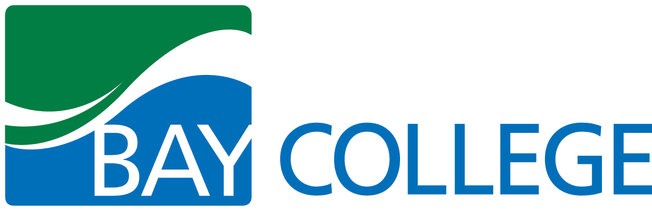
College Readiness Syllabus

GENERAL COURSE INFORMATION
- Course title: College Readiness
- Course number:
- Credits/contacts:
- Prereqs/co-reqs: CTE/DSISD
- Course dates: TBA
- Meeting days and times: TBA
- Location: Bay College Main Campus

INSTRUCTOR INFORMATION
- Name: Ashley Rogers
- Phone: 906.217.4301
- E-mail: rogersa@baycollege.edu
- Office location: 825 HUB
- Office hours: By appointment
- Office Fax #: 906.217.1618
- College address: Main Campus – 2001 N Lincoln Rd, Escanaba MI 49829

COURSE MATERIALS
- Required text(s): None
- Recommended text/materials: Notebook/binder

COURSE PURPOSE/DESCRIPTION
This course is designed to help students to prepare for the transition to college. Students will learn how to navigate the “ins and outs” of college, as well as obtain skill and strategies necessary for success in college. These skills will also transfer to the workplace and life outside of the college experience. Emphasis is placed on learning goal-setting, self-motivation, and time management. In addition, students will learn basic study skills and test taking skills. Students will also learn about the resources available to them at Bay College to support their success.

STUDENT ASSESSMENT
All Bay College students will be expected to participate in assessment activities during their course of study at the college. These activities will include participating in assessment of General Education Outcomes, classroom assessment for specific course lessons, or assessment of skills needed for a specific program. These assessments will help instructors and the college make decisions to improve instruction and student learning.

STUDENT GRADING AND EVALUATION
Non-graded.

COLLEGE POLICIES

Supplemental Instruction (SI)
Supplemental Instruction (SI) is an internationally recognized academic support program that targets traditionally difficult courses. Students come together in regularly-scheduled study sessions to compare notes, discuss course materials, develop study tools, practice problem solving, and prepare for exams. These sessions are facilitated by trained SI leaders that attend the course with students and prepare study materials for use during SI sessions. SI staff can be found in the Student Success Center (rooms 827-833 at the Escanaba Campus or room 221 at West Campus) or can be reached via phone at 906-217-4175. For more information, visit the Supplemental Instruction web page.
The TRiO Program at Bay College is a Student Support Services (SSS) Program that provides opportunities for academic and career development for low-income, first-generation college students and students with disabilities. These are some of the programs provided by TRiO:

- Academic Planning
- Career Exploration
- Transfer Assistance
- Personal Financial Training/Support
- FAFSA Assistance
- Cultural & College Trips
- Leadership Opportunities
- Grant Aid

- Tutoring in Math, Writing and General Education courses.
The Escanaba campus TRiO reception office is located in room 815 of the Student Success Center in the HUB at the Escanaba Campus or you may call 906-217-4133. The West Campus TRiO reception office is located in the Student Success Center at West Campus, or call 906-302-3035. You may also contact TRiO staff via TRiO@baycollege.edu. For more information, visit the TRiO web page.
The Bay College West Student Success Center provides tutoring to students in all courses, as well as supplemental instruction in select courses. The Student Success Center is located in room 221, on the upper level next to the Student Services Desk, (906) 302-3035.
Please refer to the college catalog for specific details about services available to students.

Bay College ADA Statement
Students requesting academic accommodations should contact the Office of Accessibility (OOA) at the Escanaba campus, room HUB 811, (906) 217-4017, OOA@baycollege.edu. If you are an individual with a disability wishing to disclose to receive disability-related accommodations or services, please contact the OOA. Reasonable accommodations and services will be provided to students if requests are made in a timely manner, with appropriate documentation in accordance with federal, state, and Bay de Noc Community College guidelines. Our online accessibility policy can be viewed at http://www.baycollege.edu/Academics/Online-Learning/Accessibility-Policy.aspx.

COLLEGE POLICIES (cont’d)

Technical Support for Online Learning
Online Learning Support is available to all Bay College students. Students can receive live support for technical issues they encounter related to online learning. For assistance, stop by Online Learning Support in the HUB at the Escanaba campus Monday-Friday 8:30 am-5 pm, call 906-217-4276 or email onlinehelp@baycollege.edu. For more information, visit the Online Learning web page.
Class Cancellation/College Closing/Notification of Emergency Situations
Weather concerns: As stated in Bay College’s Student Handbook, a reasonable effort to be present is expected. Therefore, students may exercise their own judgment as to whether or not travel to campus is warranted during adverse weather. If you decide not to travel to campus, or determine that you need to leave campus because of threatening weather, you will be expected to contact your instructor via Bay email as soon as possible to let them know why you will be absent and to discuss options for completing the missed work. Students are reminded of the opportunity to receive weather related and other emergency messages from the College through a cell phone text messaging option, called e2campus. Enrollment into the emergency notification process can be completed by visiting Bay’s website, navigating to the Campus Safety tab and following the instructions for emergency text messaging.
Academic Integrity
It shall be the policy of Bay de Noc Community College Board of Trustees that the college provides opportunities for students to gain the knowledge, skills, judgment and wisdom they need to function in society as responsible citizens. Plagiarism, falsifying data, and other forms of academic dishonesty are inconsistent with the college’s goals and mission; Students are expected to pursue their education at Bay College with honor and integrity. In line with this college policy, any student found cheating, copying, or otherwise misrepresenting his/her performance, or in any way gaining an unfair advantage over other students will be subject to disciplinary actions according to the Bay College Academic Integrity Procedures.
Course Withdrawal
It is the student's responsibility to withdraw/drop from the class if he or she chooses to do so. You may drop a class within the first two weeks with reimbursement for the tuition. You may withdraw within the third through tenth week and receive a WP (if passing at the time of the withdrawal request) or WF (if failing at the time of the withdrawal request). After the tenth week students are required to request an Administrative Appeal. All students who do not follow the drop/withdrawal procedure will receive an “F” for the class. Please refer to the college catalog for more specific details on this issue.

GUIDELINES FOR SUCCESS
Attend all sessions. Be willing to participate and learn.

COURSE OUTLINE
(To be completed Winter semester: January - May)
Week 1 | Introduction, Syllabus Explanation/Expectations,” Transition” Difference between HS and College.  College expectation and Mindfulness
Week 2 | Goal setting. College catalog, programs, and classes. How to register. Transferring.  Financial aid, Work-study, Scholarship  Academic support  Library services
Week 3 | Online learning training
Week 4 | Housing, Student activities, Title IX  College Success  Campus safety
Week 5 | Coaching, Time management  Student Panel  Course Evaluation

